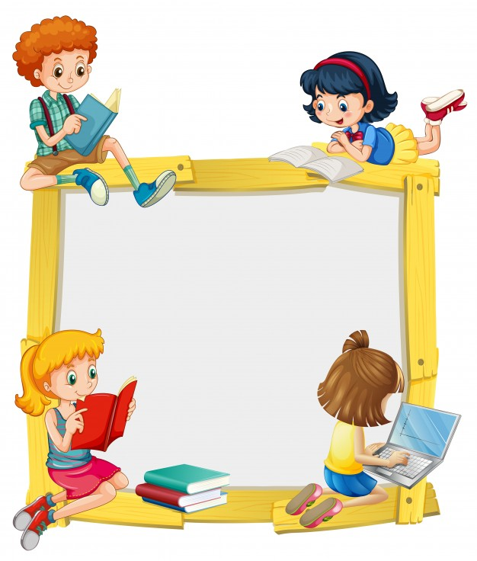
KINDERORLAND 2019-20

U K G
SYLLABUS & OVERVIEW

UKG SYLLABUS FOR 2019-20
SUBJECT/MONTHS | ENGLISH | RHYMES/ SONGS/ STORIES | MATHS | EVS
A  P  R  I  L | - Sight words  - Rhyming words  - First letter and last letter sound of words  - Short vowel sound words- a, e, i, o, u  - 3 & 4 letter word blending  - Simple sentence reading  - Make sentences | - The blue jackal  - We shall overcome | - Numbers 1 to 100  - Number names 1-10  - Pre math concept- same/different, up/down, inside/outside  - Tens and ones  - After, before and between numbers  - Backward counting 50 to 1  - Smaller and bigger number  - Missing numbers | - EARTH DAY  - EASTER  - Good habits  - Magic words  - Colour-pink  - Home -Living room, kitchen, bedroom, bathroom  - My family  - Safety at home
J  U  N  E | - Sight words  - Narrating Stories  - Short vowel sound words - a, e, i, o, u  - 3 & 4 letter word blending  - Simple sentence reading  - Make sentences  - Rhyming words | - The blue jackal  - The bear went over the mountain | - Shapes and Patterns  - Shape- Pentagon  - Backward counting 50 to 1  - Recap:  - Tens and ones  - After, before and between numbers  - Smaller and bigger number  - Missing numbers | - ID-UL-FITRE  - Meals we eat  - Food  - Season-summer, rainy, winter, spring
J  U  L  Y | - Phonic – blends - bl, pl, fl, cl, gl, sl, ss, ll, ff, zz, cr, gr, fr, br, dr, pr, tr, all, ck  - One and many  - This and That  - Reading sentences  - Make sentences  - Sight words  - Reading short Stories | - The miller, the son and the donkey  - She’ll be coming round the mountain | - Number names 11-19  - Shape-Hexagon  - Backward counting 100 to 1  - Pre math concept- thick/thin, front/back  - Forward counting 101-200  - Recap:  - Tens and ones  - After, before and between numbers  - Smaller and bigger number  - Missing numbers | - FOUNDATION DAY  - RATH YATRA  - My school- play ground and classroom  - Library and music room  - Good manners at school  - Safety at school  - People who help us at school  - Colour-purple
A  U  G  U  S  T | - Phonic – blends – ch, sh, wh, th, ng  - Digraphs - ai, oa,  - These and Those  - Sight words  - Reading short Stories | - The honest woodcutter  - VandeMataram  - Five little ducks | - Flat and solid shapes  - Shape-Sphere  - Pre math concept- on-under, open-close  - Number names-20, 30, 40, 50, 60, 70, 80, 90  - Skip counting by 2's upto 100  - Forward counting 201 to 300  - Recap:  - Tens and ones  - After, before and between numbers  - Smaller and bigger number  - Missing numbers | - INDEPENDENCE DAY  - FRIENDSHIP DAY  - Our country  - National symbols  - Famous people of india  - National festivals of India  - Religious festivals of India  - Colour-grey  - colours
S  E  M  P  T  E  M  B  E  R | - Digraphs – ea, ue, ee,  - Word families - oo  - A and An  - Opposites  - Sight words  - Reading and narrating Stories | - The hunter and the pigeons  - Did you ever see a bunny?  - Tommy thumb is up | - Number names 21 to 60  - Ordinal numbers 1 to 10  - Greater and Less than  - Skip Counting by 10's & 5’s  - Shape-Cube  - Pre math concept- more-less  - Recap:  - Tens and ones  - After, before and between numbers  - Smaller and bigger number  - Missing numbers | - GANESH PUJA  - TEACHER'S DAY  - JANMASTAMI  - Colour- orange  - Myself  - Name, age, gender  - Favourite thing  - Parts of the body  - Sense organs  - Ages and stages  - Uses of hands and legs
O  C  T  O  B  E  R | - “R” controlled vowels – er, ir, ur, or  - Phonic – ai vs ay, ee vs ea  - Word families – ou, oy  - Question / answers using Yes or No  - Sight words  - Reading and narrating Stories | - The ant and the chrysalis  - Down the jungle  - If you are happy | - Forward counting 301-400  - Shape-cylinder  - Pre math concept- first last  - Number name 100 & 61 to 100  - Recap:  - Tens and ones  - After, before and between numbers  - Smaller and bigger number  - Missing numbers | - DUSSEHRA  - HALLOWEEN  - GANDHI JAYANTI  - Colour – brown  - Places of worship  - Family celebrations  - School celebrations  - Means of Transport  - Safety at road
N  O  V  E  M  B  E  R | - Phonic – oi vs oy, magic “e”  - Position  - Days in a week  - Months in a year  - Action words  - Sight words  - Reading and narrating Stories | - The little red riding hood  - Monkeys on the fast  - Tick tock says the clock | - Forward Counting 401 to 500  - Ascending and Descending order  - Time  - Shape-cone  - Pre math concept- first last  - Recap:  - Tens and ones  - After, before and between numbers  - Smaller and bigger number  - Missing numbers | - DIWALI  - CHILDREN'S DAY  - Colour- green  - Rainbow  - The sky  - Times of a day  - Phases of the moon  - Astronomer and astronaut  - Day and Night time activities
D  E  C  E  M  B  E  R | - Word family – oa, ow, o_e  - Questions words "what", "where", "who"  - Sight words  - Reading and narrating Stories | - The ant and the dove  - Wonderful vegetables | - Addition  - Place value  - Recap:  - Tens and ones  - After, before and between numbers  - Smaller and bigger number  - Missing numbers | - CHRISTMAS  - Flowers  - Fruits and vegetables  - Germination  - Parts & uses of plants  - Care for plants
J  A  N  U  A  R  Y | - Phonics – hard “c”, soft “c”  - Word family – aw, au, al, oar, our  - Naming words  - Describing words  - Sight words  - Reading and narrating Stories | - Thumbelina  - Moo moo says the cow  - Three little kittens | - Subtraction  - Money  - Recap:  - Tens and ones  - After, before and between numbers  - Smaller and bigger number  - Missing numbers | - REPUBLIC DAY  - Animal world-sounds, babies, homes, food, uses  - Insects  - Care for animals  - Places in our neighbourhood  - People who help us
F  E  B  R  U  A  R  Y | - Phonic – Hard “g”, soft “g”  - Word family – y_e, y_i  - Use of He/She  - Simple picture comprehension  - Picture composition  - Sight words  - Reading and narrating Stories | - The monkey and the cats  - Save water | - Expanded notation  - Compact form  - Recap:  - Tens and ones  - After, before and between numbers  - Smaller and bigger number  - Missing numbers | - Sources of water  - Uses of water  - Tips to save water  - Water cycle  - Uses of air  - Water and air pollution  - Living and non living

