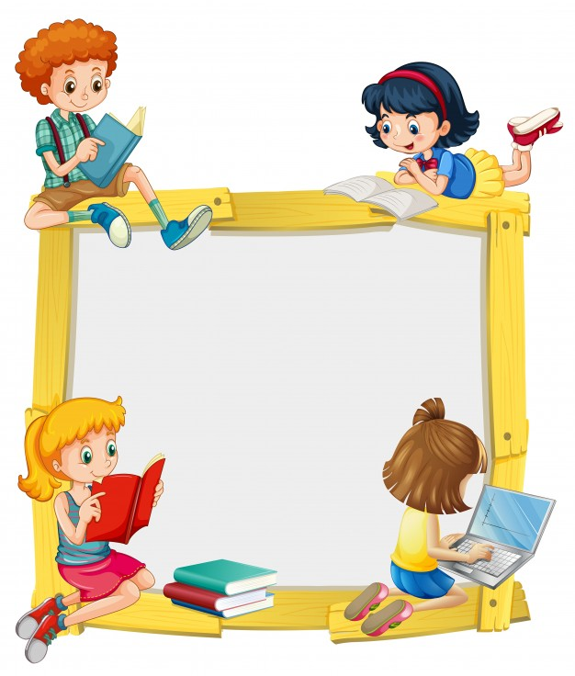
KINDERORLAND 2019-20

NURSERY
SYLLABUS & OVERVIEW

NURSERY SYLLABUS FOR 2019-20
Subject/ Month | ENGLISH | MATHS | E.V.S | RHYMES | STORIES
A  P  R  I  L | - Left /right open curve  - Sleeping line/ forward, backward, slanting line  - Identification of Small letter a, b with pictures and phonic sound | - Concept of left / right  - Shape – Circle | - Colour -Red | - You put your right | - Crane and the Fox
J  U  N  E | - Upward / Downward open curve  - Sleeping Line/ forward, backward, slanting line  - Identification of Small letter a, b with pictures and phonic sound | - Identification of number 1  - Shape – Triangle | - Colour- green | - I hear Thunder | - The three sheep
J  U  L  Y | - Identification of Letter c, d, e, f with pictures and its phonic sounds | - Identification of number 2 & 3  - Shape -Triangle | - Colour- green  - Identification of name, age  - magic words (Thank You, Please and Sorry) | - Two little hands | - Crane and the Fox
A  U  G  U  S  T | - Identification of Letter g, h, i, j with pictures and its phonic sounds  - Writing - a-d | - Identification of number 4, 5 (Counting Objects)  - Shape – Square (Name the square shape object) | - My Family  - Colour-Yellow | - Where is Thumkin  - Are you sleeping | - Tortoise & the Rabbit  - Dog & its reflection
S  E  P  T  E  M  B  E  R | - Upward loops/Downward loops, Zigzag lines  - Identification of the letters j,k,l,m with picture and phonic sounds  - Writing – e-i | - Concept of tall and short  - Identification of number 6, 7  - Number writing 1,2  - Shape – Rectangle | - About School  - Name the places in the School  - Things seen in the class room and play ground | - Bits of Paper  - Here we go round  - One Two Three | - The three Pigs
O  C  T  O  B  E  R | - Identification of the letters n, o, p, q with picture and phonic sounds  - Writing – j-n | - Identification of number 8, 9  - Number writing 4, 5  - Shape – Circle (Name the Circle shape object) | - Farm Animals  - Wild Animals  - Flowers  - COLOUR - Orange | - Here is the Bee hive  - I am a little Snow Man  - Cock-Doodle-Do... | - Elephant makes friends
N  O  V  E  M  B  E  R | - Identification of the letters r, s, t, u, v with picture and phonic sounds  - Writing – o-s | - Identification of number 10  - Number writing 7, 8  - Concept of tall/short  - in/out | - Fruits and Vegetables  - COLOUR - White | - The Apple Tree  - Cucumbers and Capsicum  - Found a Peanut | - The Fox and the Grapes
D  E  C  E  M  B  E  R | - Identification of the letters w, x, y, z with picture and phonic sounds  - Writing – t-v | - Counting numbers 1- 10  - Number writing 9, 10  - Concept of Big and Small | - Vehicles (Land, Water, Air)  - COLOUR - Black | - Ten Little Fingers..., | - The little seed
J  A  N  U  A  R  Y | - Identification of the Capital letters A-M  - Recapitulation of all the small letters (a-z Small) | - Sequencing 1 - 10  - Matching numbers with pictures  - Concept of In / Out | - Recapitulation of Colours (Red, Green, Yellow, Blue)  - Parts of Body  - About Members in the Family  - About Rooms in a Home | - Ten Little Fingers..., | - The little Hen
F  E  B  R  U  A  R  Y | - Identification of the Capital letters N - Z  - Recapitulation of all the small letters (a-z Small) | - Sequencing 1 - 10  - Matching numbers with pictures  - Concept of In / Out | - Recapitulation of Colours (Red, Green, Yellow, Blue)  - Parts of Body  - About Members in the Family  - About Rooms in a Home | - Ten Little Fingers..., | - The naughty lamb

