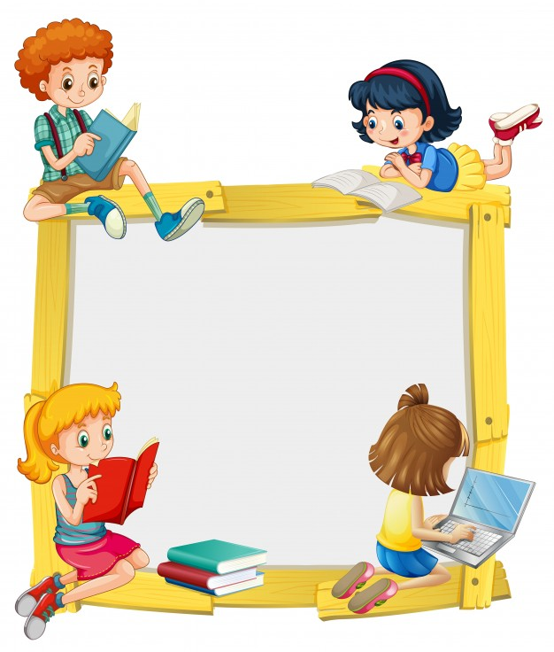
KINDERORLAND 2019-20

L K G
SYLLABUS & OVERVIEW

LKG SYLLABUS FOR 2019-20
SUBJECT/MONTHS | ENGLISH | RHYMES/ STORIES | MATHS | EVS
A  P  R  I  L | - Pattern writing.  - Introduction of the letters “s”, ”a” along with the phonic sound. | - The Cap seller and the Monkey.  - My Red Balloon.  - Brush your teeth. | - Colour- Red  - Numbers:1-5(Tens and Ones concept)  - In-Out | - Introduction of Self (Name, Gender, Age, Favourite things).
J  U  N  E | - Introduction of the letters “t” and ”i” along with the phonic sound.  - Blending 3 letter words.  - Action words. | - Incy Wincy Spider.  - Goldilocks and the three Bears | - Recap- 1-5  - Numbers-6 and 7(Tens and Ones )  - Colours- Green  - Left-Right | - Parts of the Body  - Clothes  - Magic words
J  U  L  Y | - Introduction of the letters “p”, “n”, “c/k”, “e”, “h”, “r” along with the phonic sound.  - blending 3 letter words.  - Dictation of letters through sounds.  - Sight words (I, am, a).  - Action words. | - Out in the Garden.  - Georgie Porgie  - Goldilocks and the three Bears. | - Numbers-8-10 (Tens and Ones concept)  - Big-small  - Tall-short  - After, before and between (1-10)  - Missing numbers 1-10  - Colour-Yellow, Blue and Orange  - Shapes- Rectangle | - Good habits  - Good Manners  - Good Habits  - My home  - Rooms in a home  - Safety at home  - Family  - Places and people who work there.
A  U  G  U  S  T | - Introduction of the letters “m”, “d”, “g”, “o”, “u”, “l” along with the phonic sound.  - Making words using all the letters taught  - . Dictation of letters and sound through sounds.  - Sight words (this, is, a, the, he, she)  - Action words. | - Rub-a-dub-dub  - Bits of Paper  - The Grasshopper and the Ants.  - The Two Sisters | - Recap of 1-10  - Numbers-11-20  - After and between concept  - Missing numbers 11-20  - Long-short  - Numbers 21-30  - Colours-Black and White | - My playground  - My classroom  - My library  - Safety rules at school  - Good manners
S  E  M  P  T  E  M  B  E  R | - Introduction of the letters “f”, ”b” , “j”, “v”, “w” along with the phonic sound.  - Making words using all the letters taught.  - Dictation of letters and sound through sounds.  - Sight words  - reading of short sentences  - Introduction of Rhyming words | - The talkative tortoise  - The Cracked Pot  - I Went to Visit a Farm One Day  - Mary Had a Little Lamb | - Numbers-21-40  - Missing number-1-30 and 1-40  - Recap-1-40  - After and between numbers 1-40  - Shapes-Circle and Semi-circle  - Colours- Pink and Brown | - Flowers  - Fruits  - Vegetables  - Animals(Land and Water)  - Pet and farm animals
O  C  T  O  B  E  R | - Introduction of the letters “x”, ”y” ,”z”, “qu” along with the phonic sound.  - Making words using all the letters taught.  - Dictation of letters and sound through sounds.  - Sight words  (that, have) | - A Farmer and his Three Sons  - Five Little Blue Birds | - Few-many concept  - Recap-1-40  - Number-41-50  - After and between numbers 41-50 and 1-50  - Shapes-Oval  - Colours- Purple and Grey | - Birds and insects  - Homes of animals  - Musical Instruments  - Indoor and Outdoor games
N  O  V  E  M  B  E  R | - Sequence writing of the upper and lower case.  - Matching the upper and lower case letters.  - Short “a” sounds  (at ,an, ag, ap words)  - Short “e” sounds.  (ed , et, en, eg words)  - Introduction of short sentences  - Sight words  (this, that, the, and) | - The Wolf and the Little Goats  - A Farmer and his Three Sons  - The Station | - Full-Empty and far-near concept  - Recap 1-50  - Number 51-80  - Forward and Backward Counting(1-10)  - Skip counting 2s. | - Railway station  - Vehicles on land  - Airport  - Vehicles in air
D  E  C  E  M  B  E  R | - Short “i” sounds  (it, ig, ip, in words)  - Introduction of short sentences  (reading and writing )  - Sight words(has, have) | - Pintu Found a Trumpet  - Listen to the Big Drum | - Skip counting 5s and 10s.  - Numbers 81-100.  - Missing numbers  81-100. | - Seaport and vehicles on water  - Special vehicles  - Road safety
J  A  N  U  A  R  Y | - Short “o” sounds  (ob, od, og, ot, op words)  - Short “u” sounds  (ub, ud, ug, un, ut words)  - Sight words  (on, in, was, by, so)  - Recap of the words taught.  - Sight word  (said, you, are, was) | - Pintu Found a Trumpet  - Days of the Week | - Sequence 1-100  - Number Names 1-5  - Picture addition and counting. | - Days of the week  - Month of the year
F  E  B  R  U  A  R  Y | - Recap of the words taught. | - The Lion and the Mouse  - Who took the Cookie from the Cookie Jar? | - Number names6-10  - Sequence 1-100.  - Picture addition and counting. | - Recapitulation of all the lessons taught

